SEC Form 4

FORM 4

Check this box if no longer subject to Section 16. Form 4 or Form 5 obligations may continue. See Instruction 1(b).

UNITED STATES SECURITIES AND EXCHANGE COMMISSION
Washington, D.C. 20549
 |  | OMB APPROVAL
STATEMENT OF CHANGES IN BENEFICIAL OWNERSHIP
 |  | OMB Number: | 3235-0287
 |  | Estimated average burden
Filed pursuant to Section 16(a) of the Securities Exchange Act of 1934 |  | hours per response: | 0.5
or Section 30(h) of the Investment Company Act of 1940
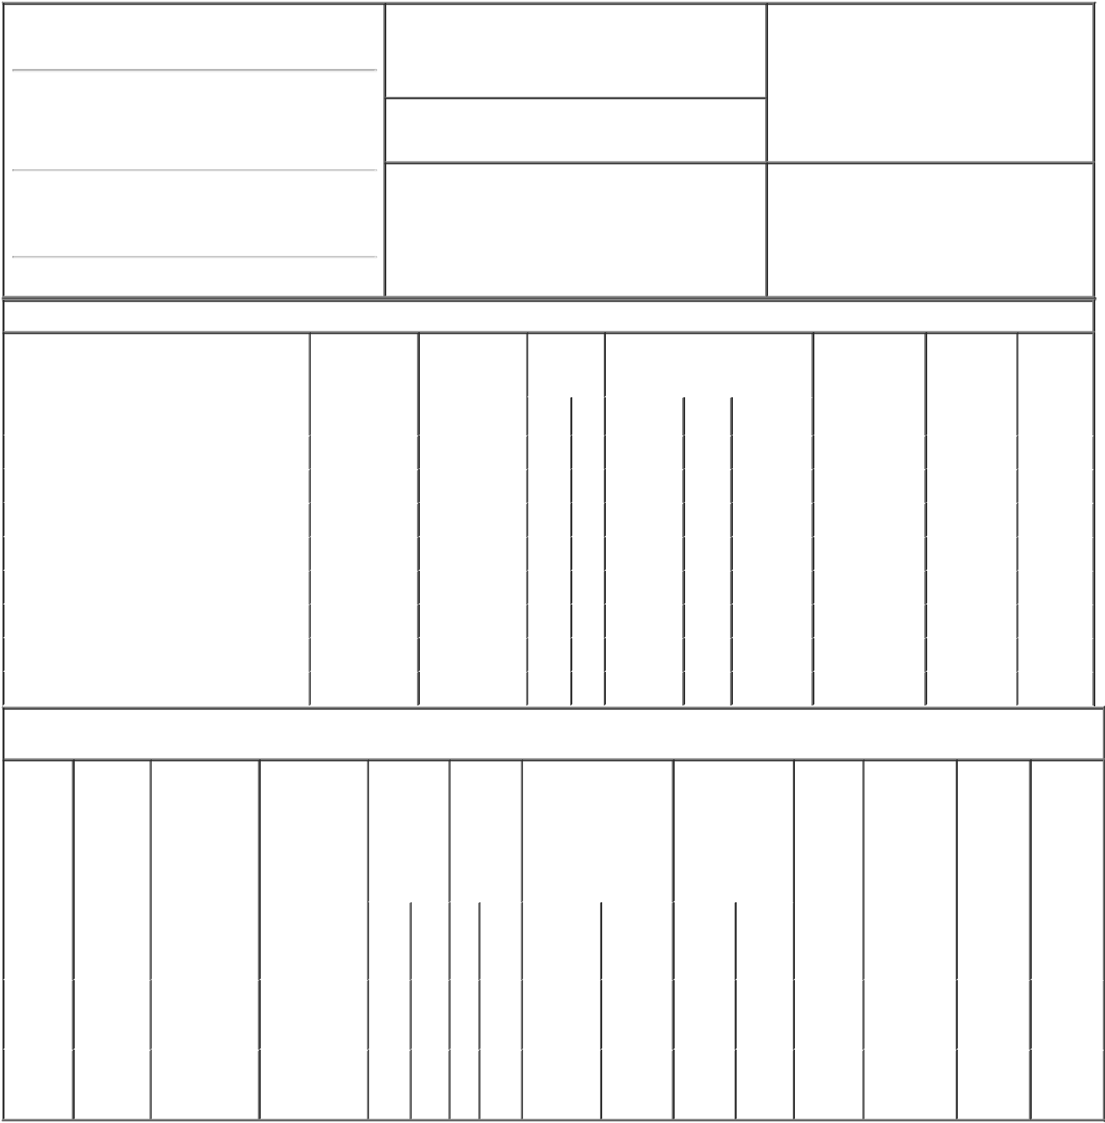

1. Name and Address of Reporting Person*
Waltermire Robert E.

(Last) (First) (Middle)

C/O MADRIGAL PHARMACEUTICALS, INC. 200 BARR HARBOR DRIVE, SUITE 200

2. Issuer Name and Ticker or Trading Symbol

MADRIGAL PHARMACEUTICALS, INC. [ MDGL ]

3. Date of Earliest Transaction (Month/Day/Year)
02/28/2023

- Relationship of Reporting Person(s) to Issuer (Check all applicable)

 | Director | 10% Owner
X | Officer (give title | Other (specify
 | below) | below)

Senior VP, Chief Pharma Dev.

(Street)

^{WEST} PA 19428 CONSHOHOCKEN

(City) (State) (Zip)

4. If Amendment, Date of Original Filed (Month/Day/Year) 6. Individual or Joint/Group Filing (Check Applicable
Line)
X Form filed by One Reporting Person

Form filed by More than One Reporting
Person

Table I - Non-Derivative Securities Acquired, Disposed of, or Beneficially Owned

 | 1. Title of Security (Instr. 3) | 2. Transaction | 2A. Deemed | 3. | 4. Securities Acquired (A) or |  |  | 5. Amount of | 6. Ownership | 7. Nature
 |  | Date | Execution Date, | Transaction | Disposed Of (D) (Instr. 3, 4 and 5) |  |  | Securities | Form: Direct | of Indirect
 |  | (Month/Day/Year) | if any | Code (Instr. |  |  |  | Beneficially | (D) or Indirect | Beneficial
 |  |  | (Month/Day/Year) | 8) |  |  |  | Owned Following | (I) (Instr. 4) | Ownership
 |  |  |  |  |  |  |  | Reported |  | (Instr. 4)
 |  |  |  | Code V | Amount | (A) or | Price | Transaction(s)
 |  |  |  |  |  | (D) |  | (Instr. 3 and 4)
 | Common Stock | 02/28/2023 |  | M | 5,000 | A | $87.92 | 10,667 | D
 | Common Stock | 02/28/2023 |  | S | 900 | D | $271.03⁽²⁾ | 9,767 | D
 | Common Stock | 02/28/2023 |  | S | 4,100 | D | $272.3⁽³⁾ | 5,667 | D
 | Common Stock | 03/01/2023 |  | M | 5,000 | A | $87.92 | 10,667 | D
 | Common Stock | 03/01/2023 |  | S | 1,928 | D | $273.44⁽⁴⁾ | 8,739 | D
 | Common Stock | 03/01/2023 |  | S | 1,672 | D | $274.57⁽⁵⁾ | 7,067 | D
 | Common Stock | 03/01/2023 |  | S | 1,300 | D | $275.53⁽⁶⁾ | 5,767 | D
 | Common Stock | 03/01/2023 |  | S | 100 | D | $276.19 | 5,667 | D

Table II - Derivative Securities Acquired, Disposed of, or Beneficially Owned

(e.g., puts, calls, warrants, options, convertible securities)

1. Title of | 2. | 3. Transaction | 3A. Deemed | 4. | 5. Number | 6. Date Exercisable and |  | 7. Title and |  | 8. Price of | 9. Number of | 10. | 11. Nature
Derivative | Conversion | Date | Execution Date, | Transaction | of | Expiration Date |  | Amount of |  | Derivative | derivative | Ownership | of Indirect
Security | or Exercise | (Month/Day/Year) | if any | Code (Instr. | Derivative | (Month/Day/Year) |  | Securities |  | Security | Securities | Form: | Beneficial
(Instr. 3) | Price of |  | (Month/Day/Year) | 8) | Securities |  |  | Underlying |  | (Instr. 5) | Beneficially | Direct (D) | Ownership
 | Derivative |  |  |  | Acquired |  |  | Derivative Security |  |  | Owned | or Indirect | (Instr. 4)
 | Security |  |  |  | (A) or |  |  | (Instr. 3 and 4) |  |  | Following | (I) (Instr. 4)
 |  |  |  |  | Disposed |  |  |  |  |  | Reported
 |  |  |  |  | of (D) |  |  |  |  |  | Transaction(s)
 |  |  |  |  | (Instr. 3, 4 |  |  |  |  |  | (Instr. 4)
 |  |  |  |  | and 5)
 |  |  |  |  |  |  |  |  | Amount
 |  |  |  |  |  |  |  |  | or
 |  |  |  |  |  |  |  |  | Number
 |  |  |  |  |  | Date | Expiration |  | of
 |  |  |  | Code V | (A) (D) | Exercisable | Date | Title | Shares
Stock
Option | $87.92 | 02/28/2023 |  | M | 5,000 | (1) | 08/02/2031 | Common | 5,000 | $0.00 | 30,000 | D
(Right to |  |  |  |  |  |  |  | Stock
Buy)
Stock
Option | $87.92 | 03/01/2023 |  | M | 5,000 | (1) | 08/02/2031 | Common | 5,000 | $0.00 | 25,000 | D
(Right to |  |  |  |  |  |  |  | Stock
Buy)

Explanation of Responses:

- All shares issued pursuant to the exercise of the options reported herein represent 10,000 shares underlying an overall option award of 35,000 shares. All exercised options had vested. As to the overall option for 35,000 shares, 25% of the shares underlying the option vested on August 2, 2022 and, thereafter, 6.25% of the shares vested, or will vest, on the last day of each successive three-month period, provided the Reporting Person continues in service with the Issuer on each such date.

- The price reported in Column 4 is a weighted average price. These shares were sold in multiple transactions at prices ranging from $270.58 to $271.47, inclusive. The Reporting Person undertakes to provide to the issuer, any security holder of the issuer, or the staff of the Securities and Exchange Commission, upon request, full information regarding the number of shares sold at each separate price within the ranges set forth in this footnote and the footnotes below.

- The price reported in Column 4 is a weighted average price. These shares were sold in multiple transactions at prices ranging from $271.82 to $272.77, inclusive.

- The price reported in Column 4 is a weighted average price. These shares were sold in multiple transactions at prices ranging from $273.00 to $274.00, inclusive.

- The price reported in Column 4 is a weighted average price. These shares were sold in multiple transactions at prices ranging from $274.06 to $274.99, inclusive.

- The price reported in Column 4 is a weighted average price. These shares were sold in multiple transactions at prices ranging from $275.18 to $276.18, inclusive.

Remarks:

As attorney-in-fact for Reporting Person

 | /s/ Brian J. Lynch |  | 03/02/2023
 | ** Signature of Reporting Person |  | Date
Reminder: Report on a separate line for each class of securities beneficially owned directly or indirectly.
* If the form is filed by more than one reporting person, see Instruction 4 (b)(v).
** Intentional misstatements or omissions of facts constitute Federal Criminal Violations See 18 U.S.C. 1001 and 15 U.S.C. 78ff(a).

Note: File three copies of this Form, one of which must be manually signed. If space is insufficient, see Instruction 6 for procedure.

Persons who respond to the collection of information contained in this form are not required to respond unless the form displays a currently valid OMB Number.

