SEC Form 4

FORM 4

Check this box if no longer subject to Section 16. Form 4 or Form 5 obligations may continue. See Instruction 1(b).

UNITED STATES SECURITIES AND EXCHANGE COMMISSION
Washington, D.C. 20549
 |  | OMB APPROVAL
STATEMENT OF CHANGES IN BENEFICIAL OWNERSHIP
 |  | OMB Number: | 3235-0287
 |  | Estimated average burden
Filed pursuant to Section 16(a) of the Securities Exchange Act of 1934 |  | hours per response: | 0.5
or Section 30(h) of the Investment Company Act of 1940
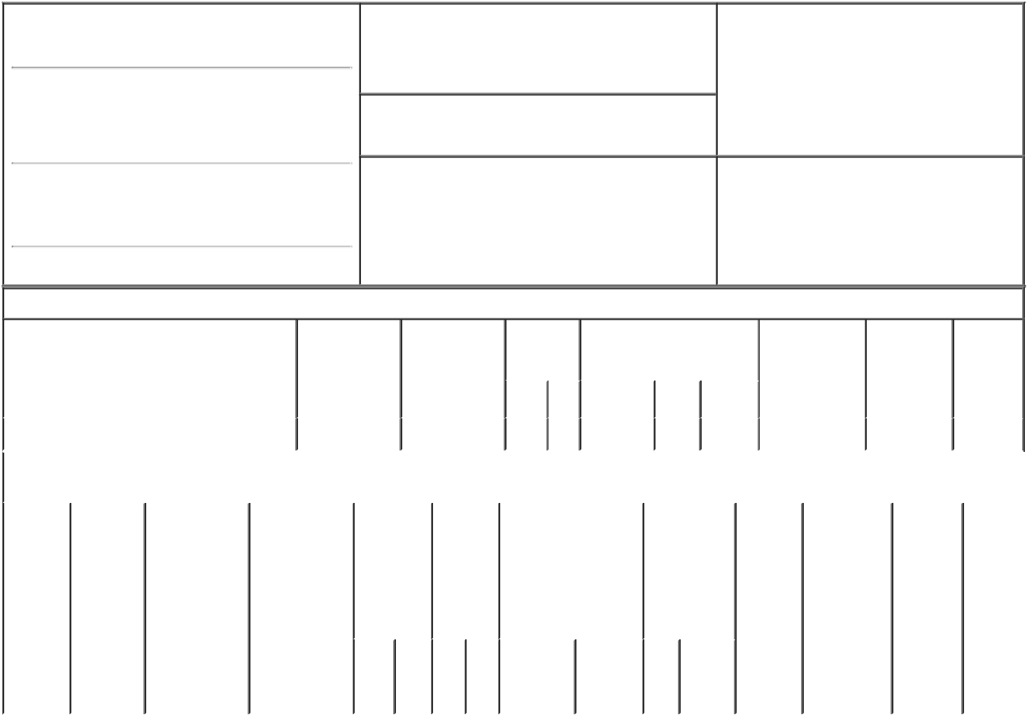

1. Name and Address of Reporting Person*
Waltermire Robert E.

(Last) (First) (Middle)

C/O MADRIGAL PHARMACEUTICALS, INC. 200 BARR HARBOR DRIVE, SUITE 200

2. Issuer Name and Ticker or Trading Symbol

MADRIGAL PHARMACEUTICALS, INC. [ MDGL ]

3. Date of Earliest Transaction (Month/Day/Year)

01/16/2023

- Relationship of Reporting Person(s) to Issuer (Check all applicable)

 | Director | 10% Owner
X | Officer (give title | Other (specify
 | below) | below)

Senior VP, Chief Pharma Dev.

(Street)

^{WEST} PA 19428 CONSHOHOCKEN

(City) (State) (Zip)

4. If Amendment, Date of Original Filed (Month/Day/Year) 6. Individual or Joint/Group Filing (Check Applicable

Line)

X Form filed by One Reporting Person

Form filed by More than One Reporting

Person

Table I - Non-Derivative Securities Acquired, Disposed of, or Beneficially Owned

 | 1. Title of Security (Instr. 3) |  |  | 2. Transaction |  | 2A. Deemed |  | 3. | 4. Securities Acquired (A) or |  |  |  |  |  | 5. Amount of |  | 6. Ownership | 7. Nature
 |  |  |  | Date |  | Execution Date, |  | Transaction | Disposed Of (D) (Instr. 3, 4 and |  |  |  |  |  | Securities |  | Form: Direct | of Indirect
 |  |  |  | (Month/Day/Year) |  | if any |  | Code (Instr. | 5) |  |  |  |  |  | Beneficially |  | (D) or Indirect | Beneficial
 |  |  |  |  |  | (Month/Day/Year) |  | 8) |  |  |  |  |  |  | Owned Following |  | (I) (Instr. 4) | Ownership
 |  |  |  |  |  |  |  |  |  |  |  |  |  |  | Reported |  |  | (Instr. 4)
 |  |  |  |  |  |  |  | Code V | Amount | (A) or |  | Price |  |  | Transaction(s)
 |  |  |  |  |  |  |  |  |  | (D) |  |  |  |  | (Instr. 3 and 4)
 | Common Stock |  |  | 01/16/2023 |  |  |  | _{A}(1) | 5,667 | A |  | $0.00 |  |  | 5,667 |  | D
 |  |  | Table II - Derivative Securities Acquired, Disposed of, or Beneficially Owned
 |  |  |  | (e.g., puts, calls, warrants, options, convertible securities)
 | 1. Title of | 2. | 3. Transaction | 3A. Deemed | 4. |  | 5. Number | 6. Date Exercisable and |  | 7. Title and |  |  |  | 8. Price of |  | 9. Number of 10. |  | 11. Nature
 | Derivative | Conversion | Date | Execution Date, | Transaction |  | of | Expiration Date |  | Amount of |  |  |  | Derivative |  | derivative | Ownership | of Indirect
 | Security | or Exercise | (Month/Day/Year) | if any | Code (Instr. |  | Derivative | (Month/Day/Year) |  | Securities |  |  |  | Security |  | Securities | Form: | Beneficial
 | (Instr. 3) | Price of |  | (Month/Day/Year) | 8) |  | Securities |  |  | Underlying |  |  |  | (Instr. 5) |  | Beneficially | Direct (D) | Ownership
 |  | Derivative |  |  |  |  | Acquired |  |  | Derivative |  |  |  |  |  | Owned | or Indirect | (Instr. 4)
 |  | Security |  |  |  |  | (A) or |  |  | Security (Instr. |  |  |  |  |  | Following | (I) (Instr. 4)
 |  |  |  |  |  |  | Disposed |  |  | 3 and 4) |  |  |  |  |  | Reported
 |  |  |  |  |  |  | of (D) |  |  |  |  |  |  |  |  | Transaction(s)
 |  |  |  |  |  |  | (Instr. 3, 4 |  |  |  |  |  |  |  |  | (Instr. 4)
 |  |  |  |  |  |  | and 5)
 |  |  |  |  |  |  |  |  |  |  | Amount
 |  |  |  |  |  |  |  |  |  |  | or
 |  |  |  |  |  |  |  |  |  |  | Number
 |  |  |  |  |  |  |  | Date | Expiration |  | of
 |  |  |  |  | Code | V | (A) (D) | Exercisable | Date | Title | Shares

Explanation of Responses:

- Represents a grant of restricted stock units, which vest as to 25% of the shares on each of January 13, 2024, January 13, 2025, January 13, 2026 and January 13, 2027, provided the Reporting Person continues in service with the Issuer on each such date.

Remarks:

**As attorney-in-fact for Reporting Person

/s/ Brian J. Lynch** |  | 01/18/2023
** Signature of Reporting Person |  | Date

Reminder: Report on a separate line for each class of securities beneficially owned directly or indirectly.

* If the form is filed by more than one reporting person, see Instruction 4 (b)(v).

- Intentional misstatements or omissions of facts constitute Federal Criminal Violations See 18 U.S.C. 1001 and 15 U.S.C. 78ff(a). Note: File three copies of this Form, one of which must be manually signed. If space is insufficient, see Instruction 6 for procedure.

Persons who respond to the collection of information contained in this form are not required to respond unless the form displays a currently valid OMB Number.

