SEC Form 4

FORM 4

Check this box if no longer subject to Section 16. Form 4 or Form 5 obligations may continue. See Instruction 1(b).

UNITED STATES SECURITIES AND EXCHANGE COMMISSION
Washington, D.C. 20549
 |  | OMB APPROVAL
STATEMENT OF CHANGES IN BENEFICIAL OWNERSHIP
 |  | OMB Number: | 3235-0287
 |  | Estimated average burden
Filed pursuant to Section 16(a) of the Securities Exchange Act of 1934 |  | hours per response: | 0.5
or Section 30(h) of the Investment Company Act of 1940
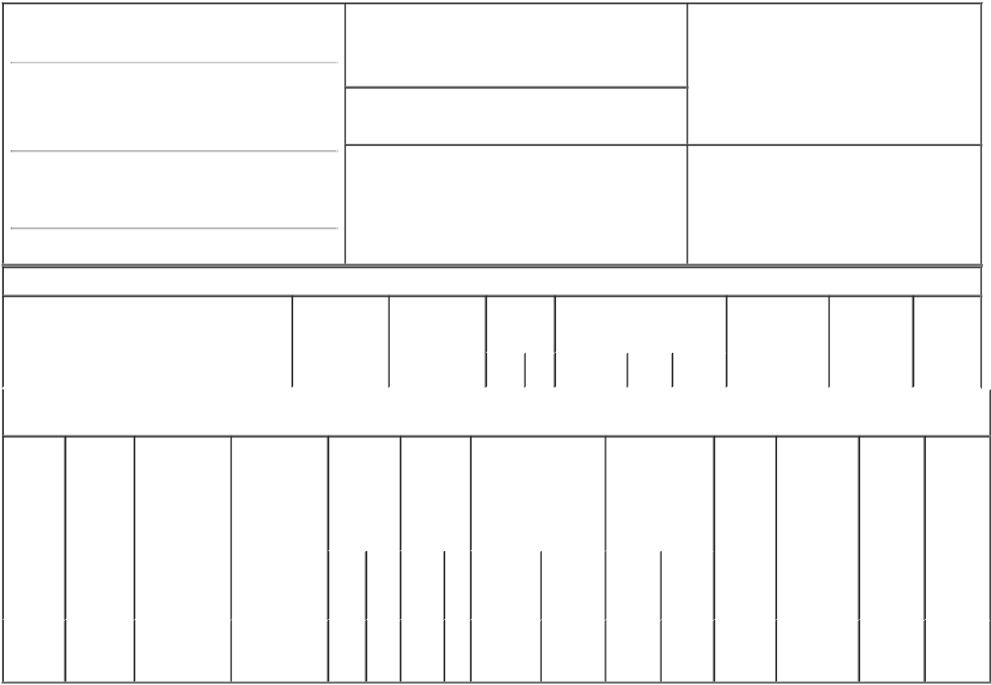

1. Name and Address of Reporting Person*
Schneebaum Marc R

(Last) (First) (Middle)

C/O MADRIGAL PHARMACEUTICALS, INC. 200 BARR HARBOR DRIVE, SUITE 400

2. Issuer Name and Ticker or Trading Symbol

MADRIGAL PHARMACEUTICALS, INC.
- MDGL ]

3. Date of Earliest Transaction (Month/Day/Year)

03/01/2018

- Relationship of Reporting Person(s) to Issuer (Check all applicable)

 | Director | 10% Owner
X | Officer (give title | Other (specify
 | below) | below)

Chief Financial Officer

(Street)

^{WEST} PA 19428 CONSHOHOCKEN

(City) (State) (Zip)

4. If Amendment, Date of Original Filed (Month/Day/Year) 6. Individual or Joint/Group Filing (Check Applicable
Line)
X Form filed by One Reporting Person

Form filed by More than One Reporting
Person

Table I - Non-Derivative Securities Acquired, Disposed of, or Beneficially Owned

 | 1. Title of Security (Instr. 3) | 2. Transaction | 2A. Deemed | 3. | 4. Securities Acquired (A) or |  |  | 5. Amount of | 6. Ownership | 7. Nature
 |  | Date | Execution Date, | Transaction | Disposed Of (D) (Instr. 3, 4 and |  |  | Securities | Form: Direct | of Indirect
 |  | (Month/Day/Year) | if any | Code (Instr. | 5) |  |  | Beneficially | (D) or Indirect | Beneficial
 |  |  | (Month/Day/Year) | 8) |  |  |  | Owned Following | (I) (Instr. 4) | Ownership
 |  |  |  |  |  |  |  | Reported |  | (Instr. 4)
 |  |  |  | Code V | Amount | (A) or | Price | Transaction(s)
 |  |  |  |  |  | (D) |  | (Instr. 3 and 4)

Table II - Derivative Securities Acquired, Disposed of, or Beneficially Owned

(e.g., puts, calls, warrants, options, convertible securities)

1. Title of | 2. | 3. Transaction | 3A. Deemed | 4. | 5. Number |  | 6. Date Exercisable and |  | 7. Title and Amount |  | 8. Price of | 9. Number of | 10. | 11. Nature
Derivative | Conversion | Date | Execution Date, | Transaction | of |  | Expiration Date |  | of Securities |  | Derivative | derivative | Ownership | of Indirect
Security | or Exercise | (Month/Day/Year) | if any | Code (Instr. | Derivative |  | (Month/Day/Year) |  | Underlying |  | Security | Securities | Form: | Beneficial
(Instr. 3) | Price of |  | (Month/Day/Year) | 8) | Securities |  |  |  | Derivative Security |  | (Instr. 5) | Beneficially | Direct (D) | Ownership
 | Derivative |  |  |  | Acquired |  |  |  | (Instr. 3 and 4) |  |  | Owned | or Indirect | (Instr. 4)
 | Security |  |  |  | (A) or |  |  |  |  |  |  | Following | (I) (Instr. 4)
 |  |  |  |  | Disposed |  |  |  |  |  |  | Reported
 |  |  |  |  | of (D) (Instr. |  |  |  |  |  |  | Transaction(s)
 |  |  |  |  | 3, 4 and 5) |  |  |  |  |  |  | (Instr. 4)
 |  |  |  |  |  |  |  |  |  | Amount
 |  |  |  |  |  |  |  |  |  | or
 |  |  |  |  |  |  |  |  |  | Number
 |  |  |  |  |  |  | Date | Expiration |  | of
 |  |  |  | Code V | (A) | (D) | Exercisable | Date | Title | Shares
Stock
Option | $124.45 | 03/01/2018 |  | A | 28,000 |  | (1) | 03/01/2028 | Common | 28,000 | $0 | 28,000 | D
(Right to |  |  |  |  |  |  |  |  | Stock
Buy)

Explanation of Responses:

- The option vests as to 25% of the shares on the first anniversary of the date of grant (March 1, 2019) and, thereafter, 6.25% of the shares shall vest on the last day of each successive three month period, provided the Reporting Person continues to serve as an officer of the Issuer on each such date.

/s/ Michael Lawhead, as

attorney-in-fact for Marc R. 03/05/2018
Schneebaum

** Signature of Reporting Person Date

Reminder: Report on a separate line for each class of securities beneficially owned directly or indirectly.

* If the form is filed by more than one reporting person, see Instruction 4 (b)(v).

- Intentional misstatements or omissions of facts constitute Federal Criminal Violations See 18 U.S.C. 1001 and 15 U.S.C. 78ff(a). Note: File three copies of this Form, one of which must be manually signed. If space is insufficient, see Instruction 6 for procedure.
Persons who respond to the collection of information contained in this form are not required to respond unless the form displays a currently valid OMB Number.

